QHiFi-SIM Software User Manual
1. Introduction
QHiFi-SIM is an open-source software platform for quantitative, high-fidelity structured illumination microscopy (SIM) image reconstruction. It integrates a traditional high-fidelity SIM reconstruction algorithm with a physics-driven neural network to correct intensity distortions, enabling both structural super-resolution and quantitative intensity accuracy.
The software provides two core operational modes:
- Mode 1: From Raw Data – A comprehensive workflow for processing raw SIM acquisitions.
- Mode 2: From SIM images – A streamlined process to enhance the intensity linearity of existing SIM reconstructions.
This manual details the functionality of each mode based on the software's graphical user interface (GUI) and underlying processing logic.
2. System Requirements & Installation
Component | Minimum Specification | Recommended Specification
Operating System | Windows 10, Ubuntu 18.04+, macOS 10.15+ | Windows 11, Ubuntu 20.04+
Python | Version 3.9 | Version 3.10 or 3.11
GPU | NVIDIA GPU with 4 GB VRAM, CUDA 11.x+ | NVIDIA GPU with 8+ GB VRAM, CUDA 12.x
RAM | 8 GB | 16 GB or more
Storage | 10 GB free space | 50 GB+ free space (SSD)
- Installation:
- Install dependencies:
pip install -r requirements.txt
Note: The cupy-cuda12x version must match your local CUDA toolkit. CPU fallback is supported but significantly slower.
- Place the pre-trained PyTorch model (e.g., best_checkpoint.pth.tar) in ./checkpoint/ or specify its path in the GUI.
- Launch the Software:
python QHiFiGUI_main.py
3. Software Interface Overview
The main window consists of two panels:
- Left Control Panel: For mode selection, parameter input, file management, and process execution. The panel dynamically updates based on the selected mode.
- Right Display Panel: For interactive visualization of SIM (left) and QHiFi (right) results, with dropdown menus to select specific output files.
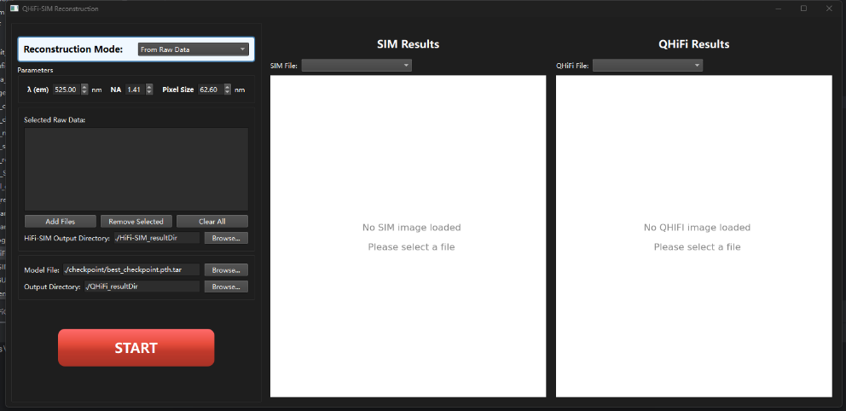
4. Mode I: Full Pipeline from Raw SIM Data
This mode is designed for users starting with raw SIM data (9 frames per acquisition). It offers two distinct usage scenarios:
- Scenario A: Perform only the high-fidelity HIFI-SIM reconstruction.
- Scenario B: Perform the complete pipeline, including subsequent neural network-based intensity correction.
Note: If you plan to use Scenario B (neural network intensity correction), you must configure the Model File and Output Directory settings before clicking "START". The software will use these settings automatically if you choose to proceed with intensity correction after HiFi-SIM completes.
Step 1 – Configuration and Input
- Set Mode: In the "Reconstruction Mode" dropdown, select "From Raw Data". This will hide the external directory inputs specific to Mode 2, but keep the neural network settings visible for potential use in Scenario B.
- Configure Imaging Parameters (Critical for PSF/OTF modeling):
λ (em): Emission wavelength (nm).
NA: Numerical aperture of the objective.
Pixel Size: Physical camera pixel size (nm).
- Load Raw Data:
- Click the "Add Files" button to open a file dialog. Select one or more raw TIFF files. Each file must contain a stack of exactly 9 images (3 phases × 3 orientations).
- Selected files appear in the "Selected Raw Data" list widget. Use the "Remove Selected" and "Clear All" buttons to manage the list. The "START" button is enabled only when at least one file is loaded.
- Set HiFi-SIM Output Directory: Specify the "HiFi-SIM Output Directory" by typing a path or clicking "Browse...". All results will be saved within a timestamped subfolder (e.g., Results_20250203_143022) created inside this directory.
- For Scenario B Users Only - Configure Neural Network Settings:
- Model File: In the "Model File:" field, verify or browse to the neural network checkpoint file (.pth.tar). This is required for intensity correction.
- Output Directory: In the "Output Directory:" field, set the path where QHiFi-corrected results should be saved. The software will create a separate timestamped folder within this directory for the final quantitative results.
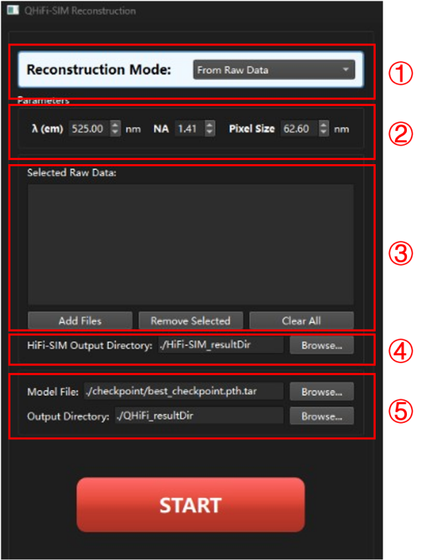
Step 2 – HiFi-SIM Reconstruction Execution
Click the prominent "START" button to begin.
- The button becomes disabled, and a progress bar appears.
- The software processes each raw file sequentially. Progress is shown as a percentage and a message (e.g., "HIFI-SIM: Processing file 2 of 4").
- Upon completion, the HIFI-SIM reconstructed image and the corresponding widefield (WF) image are saved in the timestamped results folder, under the HiFi-SIM and WF subdirectories, respectively.
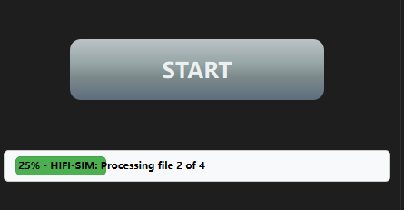
Step 3 – Decision Point: Continue to Intensity Correction?
Upon completion of the HIFI-SIM reconstruction, a dialog box pops up with the following query:
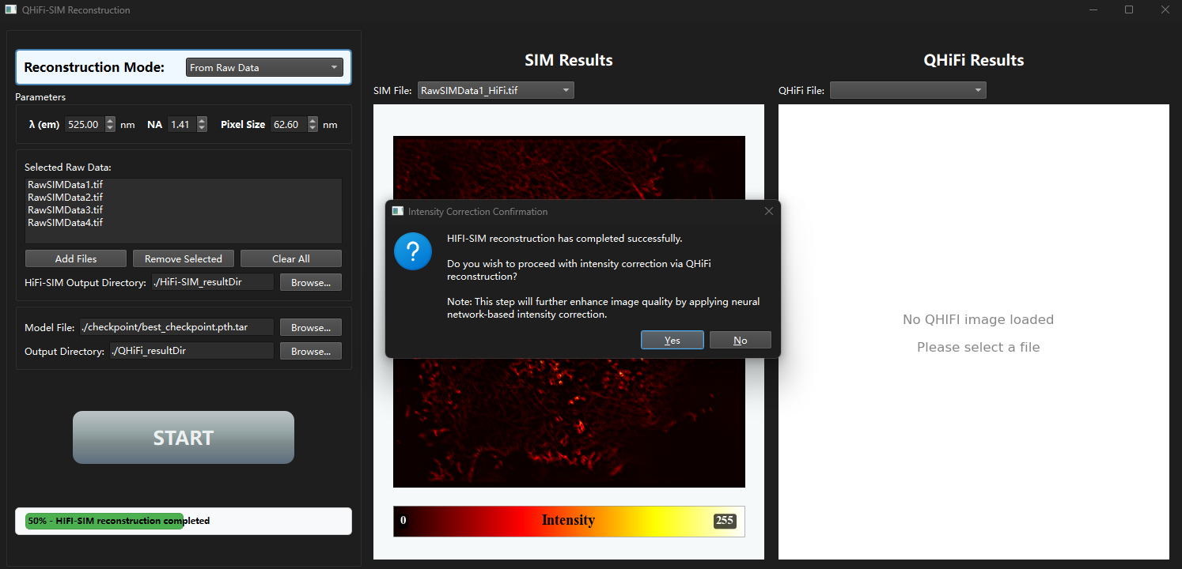
This is the branch point between the two scenarios.
- Scenario A (HIFI-SIM Only):
- Click "No". The process concludes.
- A final information dialog confirms completion, stating intensity correction was skipped.
- The progress bar shows 100%, and the control panel resets.
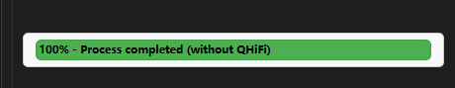
- Results Display and Visualization:
  - The "SIM File" dropdown menu in the left display panel is automatically populated with the list of newly generated HiFi-SIM result files (e.g., RawSIMData1_HiFi.tif).
  - Select any file from this dropdown to preview the corresponding super-resolution image in the left canvas. The preview includes a colorbar indicating intensity values.
  - The software intelligently searches within the designated output directory structure to locate and list the result files for display.
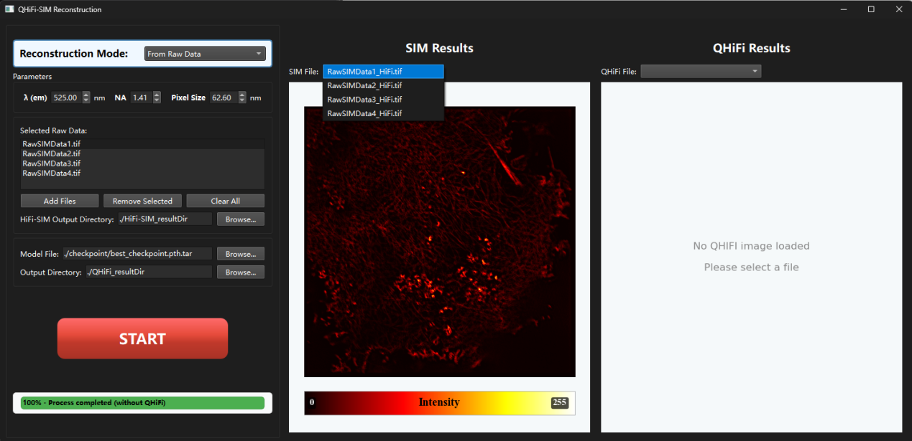
- Scenario B (Complete QHiFi-SIM Pipeline):
- Click "Yes". The software automatically proceeds to the neural network correction stage using the Model File and Output Directory settings you configured in Step 1.
- The progress bar updates (e.g., "Preparing for QHiFi reconstruction...").
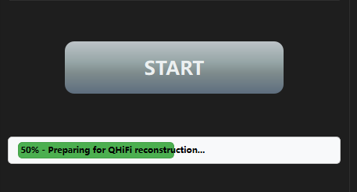
Step 4 – Neural Network Intensity Correction (Scenario B)
If you selected "Yes", the software proceeds automatically without further user input:
- The progress bar resumes and displays incremental updates (e.g., "QHiFi reconstruction: 25%").
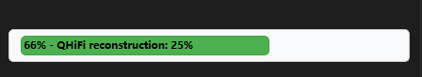
- The software loads the paired HIFI-SIM and WF images generated in the previous step. It uses the pre-configured model file to perform intensity correction. Final output is saved in a new timestamped folder within your specified Output Directory, containing the following subdirectories:
- QHiFi/: The final, intensity-corrected super-resolution image (qHiFi_xxxx.tif).
- QWF/: The neural-network-corrected widefield image (qwf_xxxx.tif).
- DWF/: A deconvolved widefield image (dwf_xxxx.tif).
- HiFi/: A copy of the input HiFi-SIM image for comparison.
- Once processing completes, the progress bar reaches 100% with a completion message, and the control panel resets to its ready state.
- Results Display and Visualization:
- Upon completion, the dropdown menus in the right display panel—"SIM File" and "QHiFi File"—are automatically updated to list the available SIM reconstruction results and QHiFi correction results, respectively.
- Selecting any file name from the dropdown menus will preview the corresponding image in its dedicated canvas. Each preview includes a colorbar indicating intensity values.
- The preview logic intelligently locates image files by searching within the output directory structure, including timestamped result folders, and excludes files containing "WF" in their names from the main lists to avoid clutter.
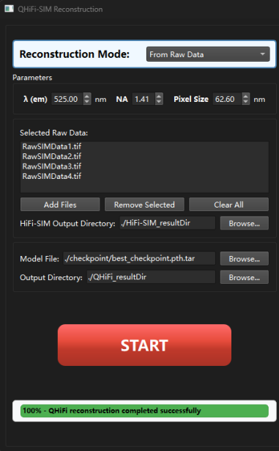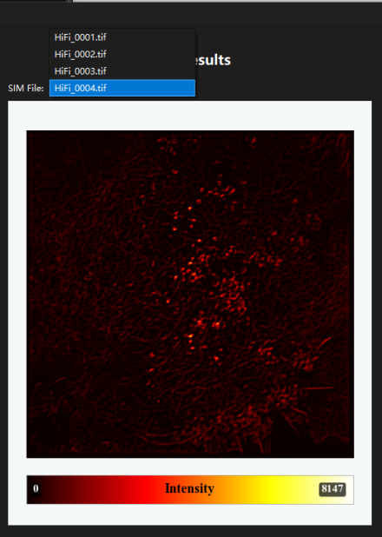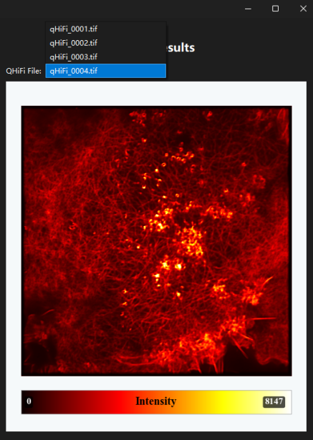
5. Mode 2: Intensity Correction of Existing SIM Images
This mode is designed for users who already have reconstructed SIM images and corresponding WF images (e.g., from a different software or a previous HIFI-SIM run) and wish to apply only the neural network intensity correction.
Step 1 – Configuration and Input
- Select Mode: In the "Reconstruction Mode" dropdown, select "From SIM images". The control panel updates, hiding the raw file list and showing directory inputs for WF and SIM images.
- Configure PSF Parameters: Input λ, NA, and Pixel Size. These are used solely to generate the correct PSF kernel for the network's fixed convolution layer.
- Specify Input Directories:
- WF Directory: Use the "Browse..." button next to the "WF Directory:" field to select the folder containing your widefield images (.tif).
- SIM Directory: Use the "Browse..." button next to the "SIM Directory:" field to select the folder containing the corresponding pre-reconstructed SIM images.
Important: Files in both directories must be numerically sorted and paired (e.g., 001.tif in WF pairs with 001.tif in SIM).
- Set Model and Output Paths:
- Model File: Verify or use the "Browse..." button to specify the path to the neural network checkpoint file (.pth.tar).
- Output Directory: Set the path for saving the QHiFi correction results by typing or using the "Browse..." button.
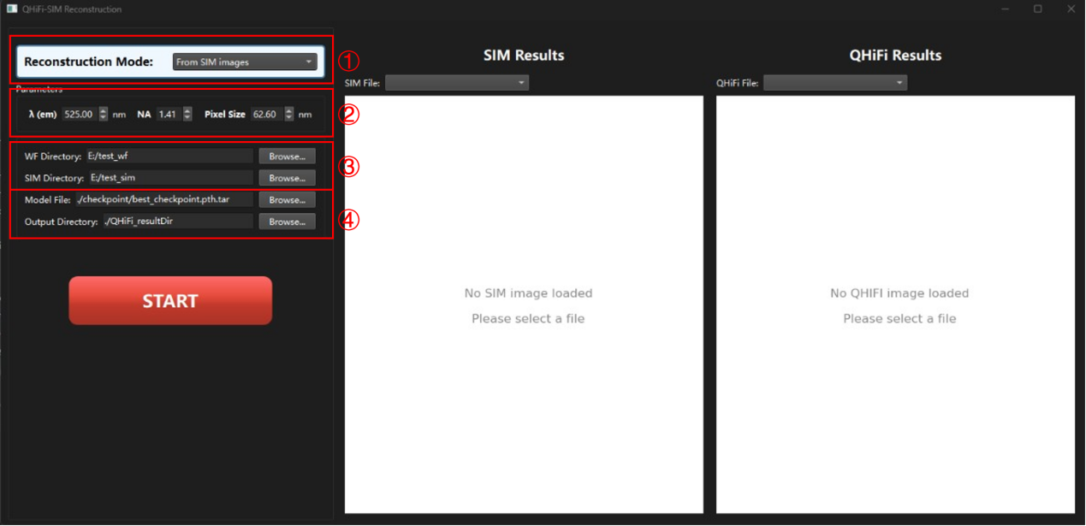
Step 2 – Execution
Click "START". The software bypasses the HIFI-SIM reconstruction stage entirely. The intensity correction process is performed, and results are saved in a new timestamped folder within your specified output directory, using the same subfolder structure (QHiFi/, QWF/, etc.) as in Mode 1, Scenario B.
- Results Display and Visualization:
Upon completion, the "QHiFi File" dropdown menu in the right display panel is automatically updated to list the newly generated QHiFi correction result files.
Selecting a file name from the dropdown will preview the image with an accompanying colorbar indicating intensity.
The software intelligently locates the result files within your specified output directory for display.
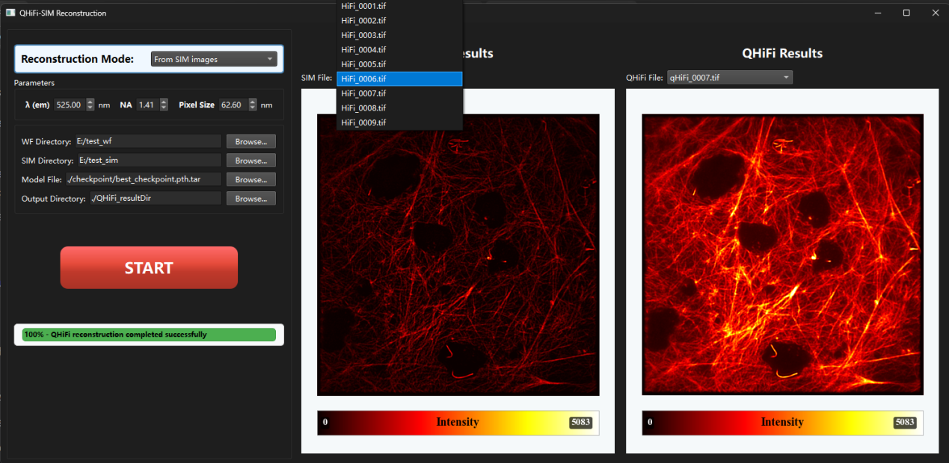

6. Quantitative Intensity Analysis
After any QHiFi reconstruction (in either Mode), a dialog box appears asking whether to run quantitative intensity analysis.
6.1 Trigger
In Mode 1 (Scenario B), after the QHiFi reconstruction finishes.
In Mode 2, after the QHiFi reconstruction finishes.
6.2 Operation Steps
Confirm: Click “Yes” to start the analysis, or “No” to skip.
Select directories (when “Yes” is clicked):
- WF Directory: Folder containing the original widefield images (matched to SIM images by file name).
- SIM Directory: Folder containing the SIM reconstructed images.
- GT Directory (optional): Folder containing ground‑truth images (for further evaluation). Click “Cancel” to skip if not available.
6.3 Output Results
The analysis creates a subfolder Quant_Analysis inside the QHiFi output directory, containing:
- Content Description
- R2_summary.xlsx Comprehensive metrics summary: pixel‑wise R², 6×6 and 12×12 patch‑sum R², PSNR, SSIM for each sample.
- ROI_sum_tables/ Per‑sample ROI intensity tables (6×6 and 12×12), including WF, SIM, DWF, QWF, QSIM pixel sums and their ratios.
- Difference_Images/ Difference images: DWF‑WF, QWF‑WF; if GT is provided, also QWF‑GT, QSIM‑GT, SIM‑GT.
- ROI_marked_images/ Images with ROI boundaries drawn (yellow boxes) for visual verification.
- Pixel_values/ (Only if GT is provided) Pixel‑level data Excel file with intensity ratios (DWF/WF, QWF/WF, SIM/GT, QSIM/GT).
6.4 Metrics Explanation
- PSNR (Peak Signal‑to‑Noise Ratio): Pixel‑wise difference between corrected and reference images.
- SSIM (Structural Similarity Index): Measures structural similarity.
- R² (Linearity): Assesses linear correlation between corrected images and the original WF, computed at pixel level, 6×6 patch sums, and 12×12 patch sums.
- ROI ratios: Ratios of pixel sums in automatically sampled foreground regions (e.g., DWF/WF, QWF/WF) to quantify intensity linearity.
7. Troubleshooting & Notes
- CuPy not available: If CuPy is not installed, the software falls back to CPU, which may be very slow. Check that the correct cupy-cudaXX version is installed.
- File count mismatch: Ensure that WF and SIM folders contain the same number of files and are paired by the same numeric prefix.
- Raw data format: Each raw TIFF must have exactly 9 frames (3 orientations × 3 phases).
- PSF parameters: Incorrect λ, NA, or pixel size will affect the PSF generation and thus the reconstruction quality.
8. License
This software is licensed under the MIT License.
See the LICENSE file in the repository root for details.
Nothing in this repository grants a patent license.

